**Experiment No 01: Identification of the problem and determination of the PEAS Descriptor.**

**Aim:** Identification of the problem and Determination of its PEAS Descriptor.

**Objective:** To analyze the Performance Measure, Environment, Actuators, Sensors (PEAS) for given problem before building an intelligent agent.

**Theory:**

The goal of AI is to build intelligent system which can think and act rationally. For each possible percept sequence, a rational agent should select an action that is expected to maximize its performance measure, given the evidence provided by the percept sequence and whatever built-in knowledge the agent has. Rationality is relative to a performance measure.

Designer of rational agent can judge rationality based on:

* The performance measure that defines the criterion of success.
* The agent prior knowledge of the environment.
* The possible actions that the agent can perform.
* The agent’s percept sequence to date.

When we define a rational agent, we group these properties under PEAS, the problem specification for the task environment.

**Performance Measure:**

If the objective function to judge the performance of the agent, things we can evaluate an agent against to know how well it performs.

**Environment:**

It the real environment where the agent need to deliberate actions. What the agent can perceive.

**Actuators:**

These are the tools, equipment or organs using which agent performs actions in the environment. This works as output of the agent. What an agent can use to act in its environment.

**Sensors:**

These are tools, organs using which agent captures the state of the environment. This works as input to the agent. What an agent can use to perceive its environment

**PEAS Descriptors Examples/Problems:**

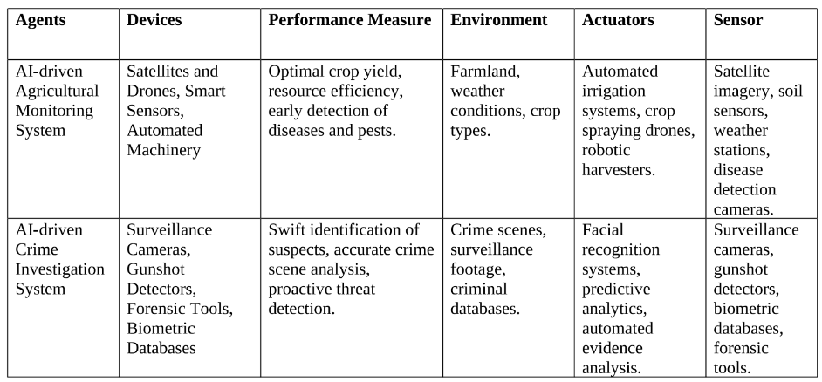

**Conclusion:** Hence we have implemented PEAS, which stands for Performance, Environment, Actuators, and Sensors, is a comprehensive framework for designing intelligent systems. It includes a speedometer, problem-solving, and natural language processing (NLP). PEAS descriptions emphasize crafting AI model’s adept at real-world scenarios by capturing the dynamic interplay of these key elements. Moreover, PEAS, a crucial performance metric, will continue to be crucial for AI researchers and engineers, offering guidance in constructing intelligent systems that excel within their specific domains.